# Canceled Flight = Unexpected Road Trip

We made it all the way home to Idaho Falls this week - - Hooray!!! It was a super fun week, packed FULL to the brim, along with some twists and turns that we didn't anticipate as well.

Monday:

We left our house in Vicenza just after 6:30 a.m. to catch the shuttle bus to the Venice Airport. We got there in plenty of time to sit around for a while and start playing on our phones, ha ha.



We flew on Tap Air Portugal to Lisbon, Portugal where we had about 2 hours to wait for our final flight. I found a couple of cute gifts in the Lisbon Airport that were inexpensive.

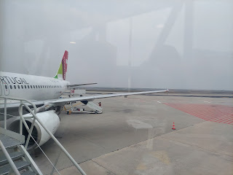

One of those gifts was a can of local sardines for Jacob and Hannah. I wish that I had gotten a photo of the store because it was so bright and colorful and so beautifully organized!! If you've ever been in an M&M's store, you'll understand what I'm trying to describe. In the M&M store everything is bright and cheery and organized by color. (They speak my OCD love language when it comes to organization, ha ha)

I just found these photos online of the sardine store in Lisbon . . . isn't it a pretty store?

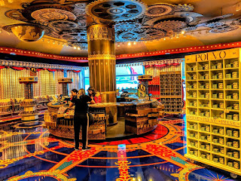

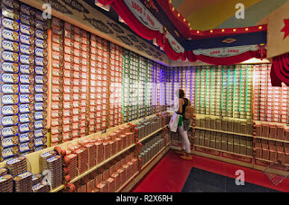

Cans and cans of different flavored "tins" of sardines . . . They even had tins of octopus, cod, and other fishes. I asked the guy for some suggestions on what to buy and he said that the fan favorite is just a simple, basic sardine in olive oil. He said the people of Portugal don't need anything fancy.

So I followed his suggestion for Jacob. Our son sent us this picture a couple days ago with the caption:

"This can was so good I ate the whole thing by hand in a few seconds, getting faster the more I ate."

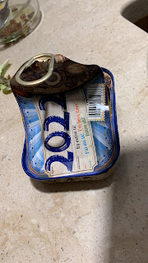

I'm glad to know they were as tasty as the salesman told me they were!! I got Jacob another can, but with some cod in it instead of more sardines. He is eager to try that one soon and said he'll report back to let us know what he thinks of it. :)

Our flight was delayed by an hour, but eventually we got settled on board and started the 8.5 hour flight across the Atlantic to Washington DC. They served us a pretty tasty meal on the plane: Chicken in a simple but flavorful red sauce, with rice and a piece or two of broccoli; a side salad consisting of chopped turkey lunchmeat along with an olive, some slices of cucumber and a drizzle of olive oil; some crackers with a soft Brie (or similar) cheese; a dinner roll; and the red cup contained some rice pudding. I gave my roll to Scott but I ate most of the rest and it was really good. :)

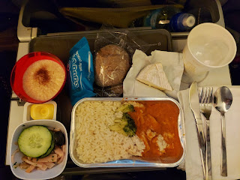

I watched the first Harry Potter movie (The Sorcerer's Stone) so that I could have something to chat about with Abby later in the week. She's read through THREE of the Harry Potter novels in recent weeks!! She's only 7 1/2 years old!!!

That was the only movie I watched during the entire flight. I was pretty tired, so I closed my eyes for a long time. We were lucky because one of the 3 seats in our row was vacant, which meant that I could put the arm rest up and then curl up as best as I could to rest.

View from the air leaving Lisbon . . .

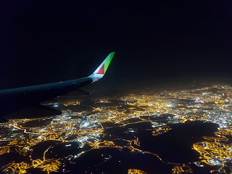

Coming into Washington DC . . .

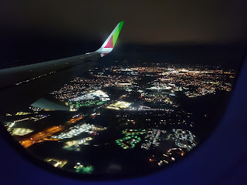

Video as we landed back on U.S. soil: HOORAY!!! (40 seconds)

https://photos.app.goo.gl/uueS2YJ2GPm4t9ik7

We got in pretty late so Jacob ended up driving 40 minutes to pick us up at Dulles Airport. The original plan was for us to hop on the new Silver Line (metro) from the airport to Ballston Station, which is much closer to their house. But by the time we landed, the last train was done for the night leaving from the airport . . . Thankfully, Jacob figured that out while we were in the air and made his way over to get us all on his own. What a good son.

By the time we went to bed, it was around 1:00 a.m., which was 9:00 a.m. back in Italy.

Tuesday:

We woke up earlier than we wanted to, ha ha. We slept on an air mattress in Jack's bedroom, while he slept in his Pack & Play in his parents' large walk-in closet. It was plenty comfortable for us after that long flight.

We took Jack on a walk to a nearby park before lunch. He's getting so good at climbing!

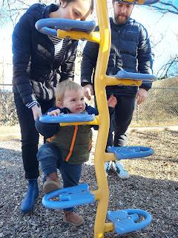

Video of Jack climbing up the steps, with a little help from Jacob: (21 seconds)

https://photos.app.goo.gl/HdkxemABojfiFz5z7

Video of Jack enjoying the slide, especially with a fire truck: (27 seconds)

https://photos.app.goo.gl/zG5UQkwyPNb7KL1M7

Video #2 of Jack coming down the slide: (23 seconds)

https://photos.app.goo.gl/p8tfmX2692vLAp1p6

After Jack's nap was all done later in the afternoon, we squished into the car and drove about 40 minutes to the Washington DC Temple. It was absolutely gorgeous with all the Christmas lights everywhere!

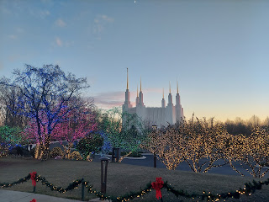

Pictured below: (L to R) Scott, me, Hannah, Jacob and Jack

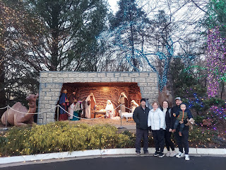

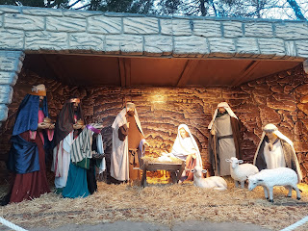

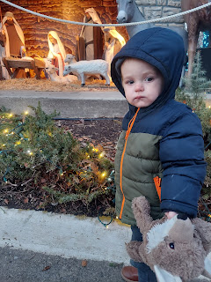

Next to the temple is the Temple Visitor Center. It's quite large inside and has some really beautiful exhibits. I loved how they have a display showing the inside of the temple, room by room. There is a baptistry, some endowment rooms, some sealing rooms, and the most beautiful room of all is the Celestial Room.

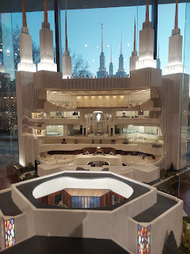

For more information about temples and why we have them, here is a good link:

https://www.churchofjesuschrist.org/temples/why-latter-day-saints-build-temples?lang=eng

A live tour of the Washington DC Temple (11 min, 45 sec)

https://www.churchofjesuschrist.org/media/video/2022-05-0020-welcome-to-the-washington-dc-temple?lang=eng&alang=eng

Short video to answer the question: Can I go inside a Latter-day Saint Temple? (1 min, 5 sec)

https://www.youtube.com/watch?v=xSiwmYzSYTM&ab_channel=ComeUntoChrist.org

The Visitor Center also shared some of the timeline and fun facts about the building of the Washington DC Temple:

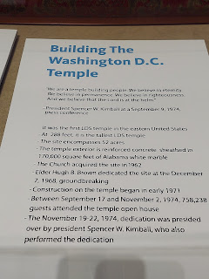

There were also models on display of some ancient temples, such as in Old Testament times, and an explanation of their significance and purpose.

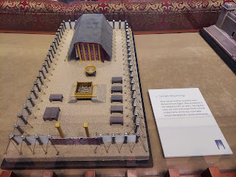

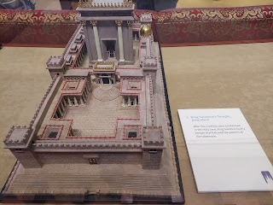

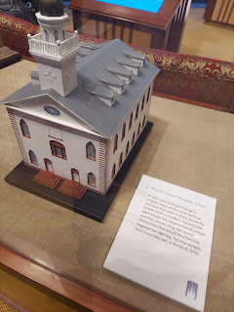

We had plenty of adults to keep track of Jack, who freely wandered throughout the Visitor Center. He loved the fluffy sheep hanging on this tree . . .

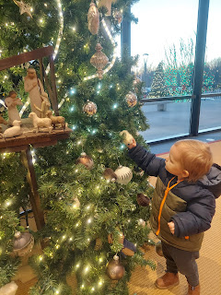

Within the Visitor Center is also a large and beautiful display of several Nativity sets from around the world.

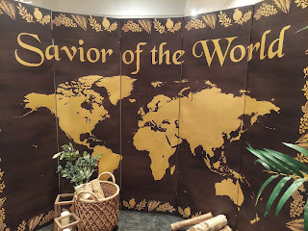

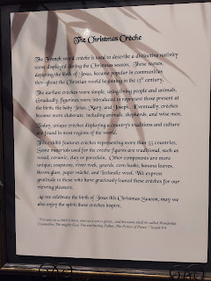

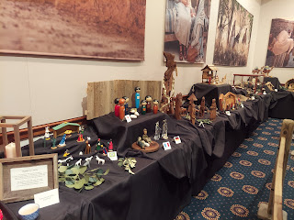

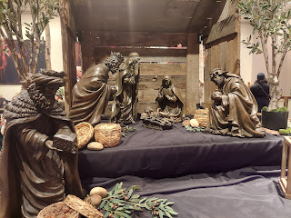

Zambia and Madagascar

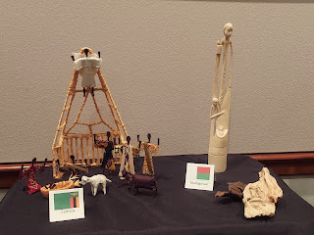

This was a very interesting and unusual "Nativity" from the USA . . . I tried to keep an open mind as I tried to understand what the artist wanted to portray. Again, just as with some of the Nativity sets back in Verona, Italy, maybe the message is that Christ is meant for each of us, no matter where we live or what time period we are from. He is available to us all.

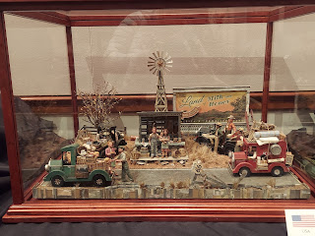

Ukraine

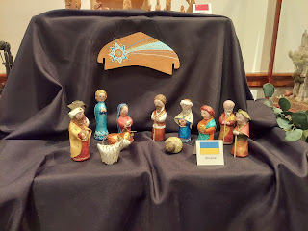

USA (I loved the beautiful blue tones of this one)

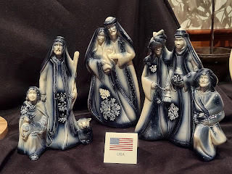

Fiji

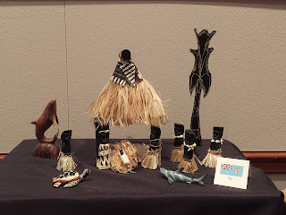

Oman (top) and Poland (below)

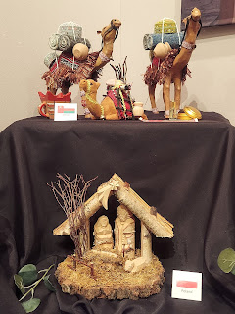

There were MANY more Nativities on display, and we enjoyed seeing them all very much. :)

Jacob found a little nook with a TV and a comfy place to watch a short video about temples. He didn't want to leave, ha ha.

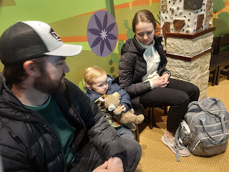

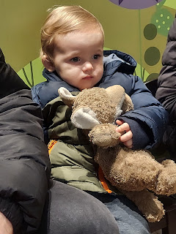

Hannah, Jacob and Jack

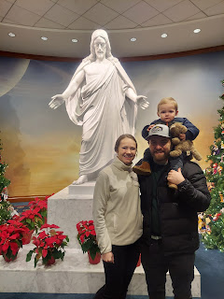

When we ventured back outside, the lights were even more profound because the sun had gone down. WOW.

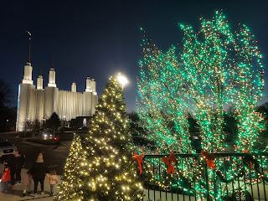

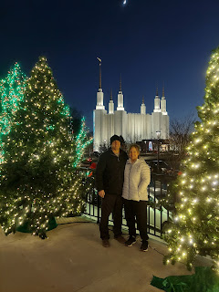

I enjoyed taking several photos, trying to capture the temple reflection, the lights, and the moon up in the sky.

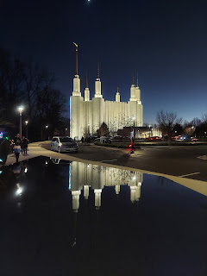

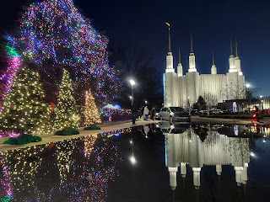

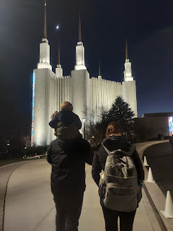

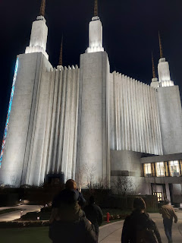

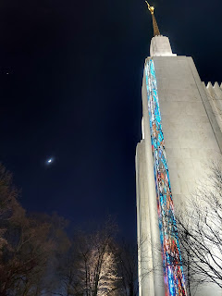

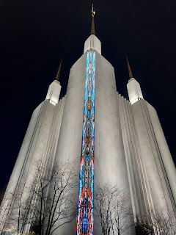

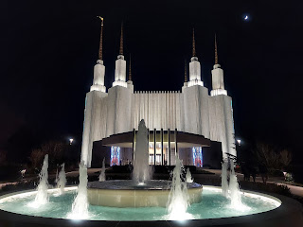

Another beautiful life-size Nativity was outside the temple . . . Jack was so excited to go over and give some love to the sheep.

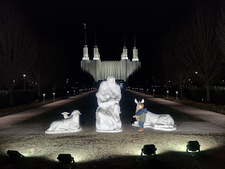

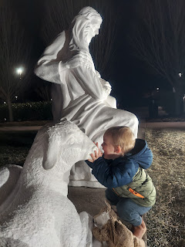

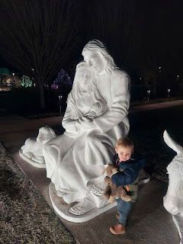

On our way back to the car, he found himself a nice long stick . . .

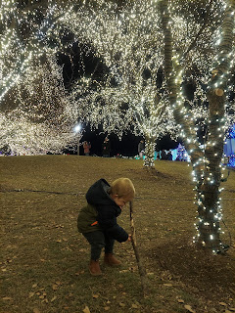

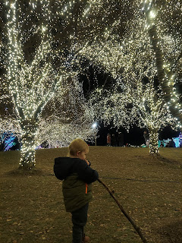

To then take a taste of . . .

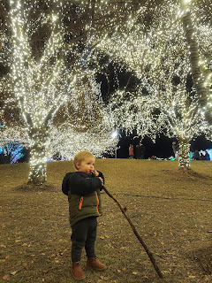

Goodbye beautiful temple with all your beautiful lights . . .

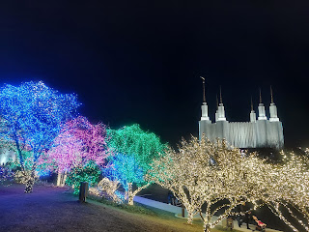

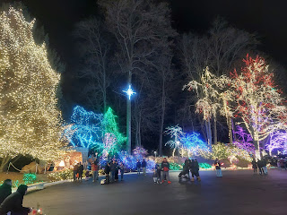





Back to Jacob and Hannah's place, where they prepared us a tasty feast. Pan-fried cod, with a lovely green salsa to spoon on top, and a cabbage/onion/tomato salad on the side. He is such a good cook and I always get excited to eat something that he's made.

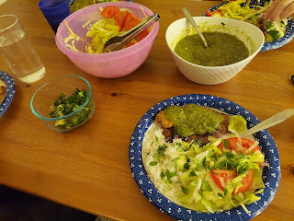

Wednesday:

Scott and I woke up to learn that our flight down to Dallas was indeed canceled. We had received a notification from Southwest Airlines on Monday, but we didn't belive it. Why would they cancel a flight 3 days in advance? We couldn't see our flight number that far in advance, so we had to wait until Wednesday to verify the information. Yep, it was canceled! And there was nothing available for us to change our flight to.

The Southwest website was like a ghost site . . . their flight schedule was completely empty for the rest of the week!! And not just flights on the east coast. Flights were canceled across the entire country for no apparent reason.

We quickly began exploring other options, but the best one that surfaced was just to rent a car and drive ourselves down to Dallas. Other airlines had a few flights, but trying to buy one 24 hours in advance meant that they were a bit spendy. Bus . . . nope. Train . . . nope. They both would take about 3 days to get us there. So the rental car became our hero.

We took care of the details early in the morning (since we had woken up extraordinarily early again) before the rest of the family got up. We requested a refund from Southwest, booked a rental car for $60/day, and lined up a hotel along the route. I couldn't believe that the rental car was such a good price, because usually when you reserve a car "one-way", they gouge you big-time. ($$$) We kept wondering, what's the catch??

I'm jumping ahead, but when we picked up the car the following morning, they told us at the Enterprise counter that people were renting cars to drive themselves as far away as CA because of their canceled flights! So that led me to believe that maybe the rental car industry was in the middle of a giant CAR SWAP. Maybe that's why we got such a good rate . . . because everyone was just doing a big shuffle of cars and that everyone's fleet would turn out to be just fine in the end.

After a tasty breakfast (Jacob made us some banana/chia seed/flax meal pancakes that were exceptional!!), we hung out and sort of "decompressed" after our frantic (and lengthy) research and alternate planning. We made a good team, though.

Video of Scott throwing Jack into the air, which he wanted over and over: (33 seconds)

https://photos.app.goo.gl/8mZ4auCADJUeMWty6

Scott even noticed at one point that Jack was mouthing "one...two...three!!" as he anticipated being tossed up to the ceiling, ha ha.

We walked to another park, this one a bit further away, but super fun!

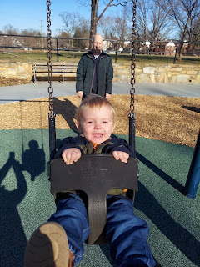

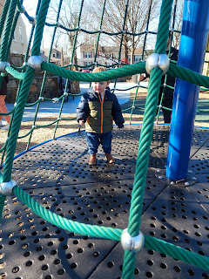

Jacob climbed up to the top of this huge jungle gym with Jack and they came down the slide together. Later, Jack went down by himself on his tummy.

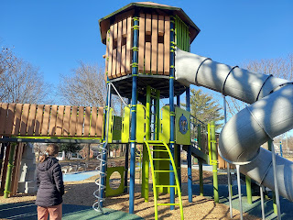

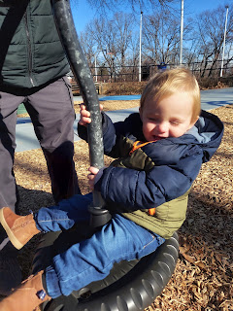

This was a fun swing for grownups too!

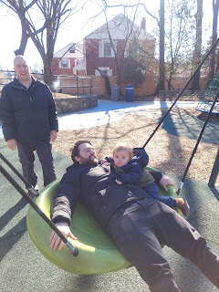

Jack enjoyed watching all the dogs running around across the street at the dog park.

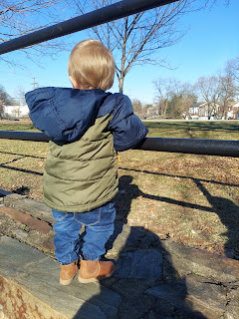

Video of Jack on the swing: (11 seconds)

https://photos.app.goo.gl/MLZoQywY44ymwzoP6

Video of Jack inside the netted merry-go-round: (27 seconds)

https://photos.app.goo.gl/vvpFqAh93KbnBgmz7

During Jack's nap that afternoon, Gordon and Pam came to visit all of us. (Scott's brother and his wife) We had fun catching up and hanging out until Jack woke up. Then we went out to an early dinner at Nando's - a chicken and sides place. YUM!!!

We ordered 2 whole chickens for the 6.5 of us, with fries, Brussels sprouts, and sweet potatoes.

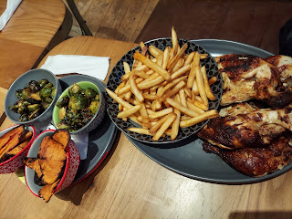

From the left: Jacob, Jack, Hannah, me, Pam, Scott, and Gordon

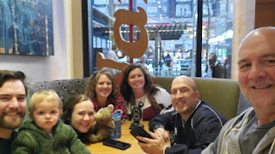

Nando's is located at Pentagon City, a huge shopping area near the Pentagon, with several restaurants and even a Costco. They also have an outdoor ice skating rink! As we came out of Nando's we saw a girl just finishing up her rounds to smooth and correct the surface of the ice by driving a Zamboni. Pretty cool.

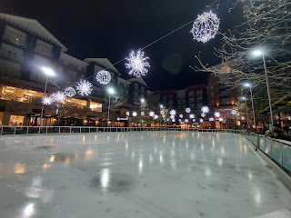

At bedtime, we had to say our goodbyes to Jack . . . how sad. We knew we would be getting up early the next morning to begin our drive south, and we wouldn't be able to hug him in the morning.

First we had to drive some cars and trucks around on the rug for a bit . . . I showed him how he could use those grey stripes as "roads".

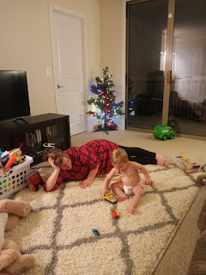

Then it was hug and squish time.

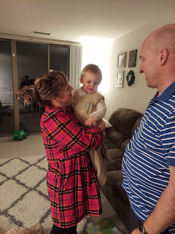

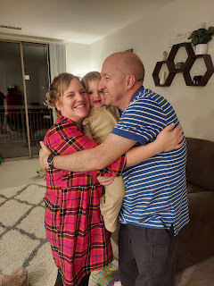

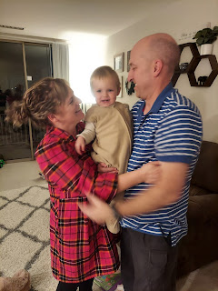

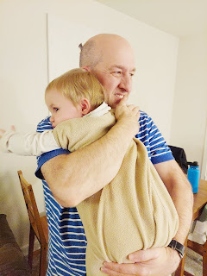

Jack absolutely adores the men in his life, as apparent by how much he wanted Scott over me . . .

Video of us trying to capture how Jack was patting Scott gently on the face and on the back as they hugged and hugged, but then he got distracted by me using my phone to take a video: (19 seconds)

https://photos.app.goo.gl/xKcCP7FjnVQts4cw8

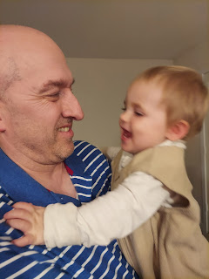

Jack giving kisses . . .

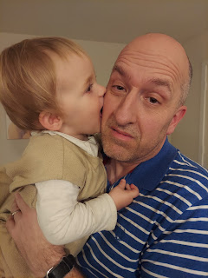

Every time his parents would take him out of Scott's arms to haul him off to bed,  he would turn around and reach back for Scott. It was really precious. Jacob was the same way as a little boy. He also adored the men in his life: his father, the grandpas, and all of his uncles.

We will sure miss Jack and his parents. We had a very fun two days with them.

Thursday:

Jacob drove us over to Reagan National Airport at 6:30 a.m. to pick up our rental car. It's only about 7 minutes from their house.

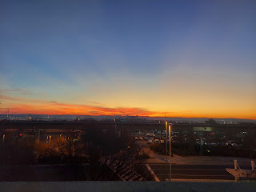

We could choose any car we wanted from the section they directed us to. We chose the black Mazda CX because it had a larger trunk space and comfy leather seats up front for our loooooong drive ahead.

Goodbye Arlington and Washington DC . . .

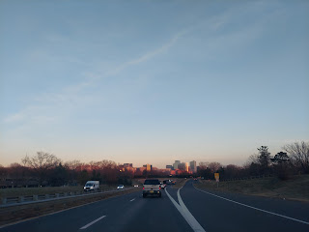

Our Day One consisted of a good 13+ hours of driving. Blech. We drove slightly NW at first to then head south through the Shenandoah Valley. I was happy to see that this would be part of our route. It brought me right back to all the time I spent there back in early 2020 as I did family history for a whole month and stayed with Gordon and Pam.

Lots of farms and beautiful countryside through the Shenandoah Valley.

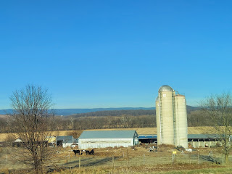

I had a LOT of wonderful memories come flooding back as we passed by Strasburg. I found several ancestral lands and roads, houses, and stomping grounds there almost 3 years ago.

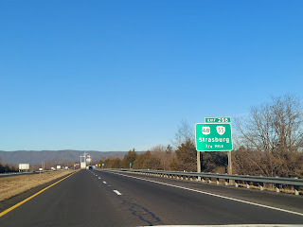

At one point during our long day, we looked on Google Maps for a grocery store. The one we chose turned out to be a mini mart, ha ha. Nothing healthy there for sure. Just chips and nuts and beverages. But this bag of chips looked interesting! The first round tasted great. The second round a few hours later wasn't as enjoyable. It was just a little too salty for my liking.

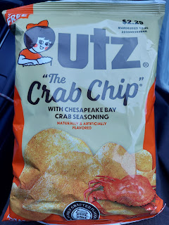

For lunch, we stopped at a cute and tasty cafe called "Chicken Salad Chick" in Bristol, TN. There is a Bristol, VA just across the state line, which could be confusing if you say you're from Bristol!!

The restaurant offered several types of chicken salad or egg salad. The descriptions were pretty cute.

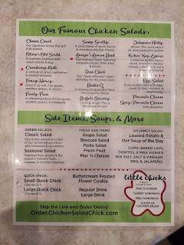

I got the Sassy Scotty sandwich on a croissant and it was so yummy (see below). Scott took the suggestion of the cashier and, after trying a sample first, selected a chicken salad that was "off menu". It was called "Deck the Holly", with some chopped jalapenos and cranberries in the chicken salad. He loved every single bite.

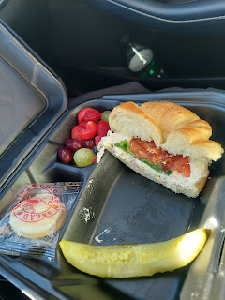

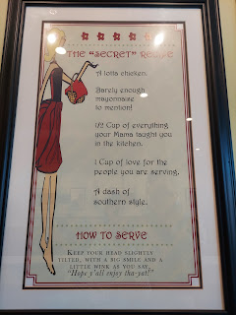

We spent most of the day just driving across Tennessee. I was surprised at how long that took!! From Bristol where we crossed from VA into TN and across to Memphis was 7.5 driving hours!!

I had done a little bit of family history research before we left Jacob's house, because I knew that our Tarwater family came from the Knoxville area. I was hoping to find something we could see as we drove through there.

One of the documents stored in my Google Drive was very helpful. It was sent to me by Jeffrey Harmon, a family history expert down in Southern CA when I was researching the Tarwaters from Murrietta, CA back in 2018.

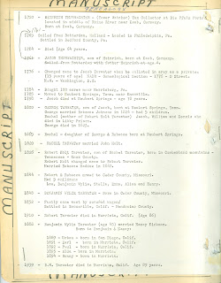

A distant cousin, Ron Wickerd, researched the Tarwater line and put this together (not sure when exactly). He has some very specific information that sounds pretty amazing, while other details don't quite add up (like some of the dates and the timeline).

He mentions Neubert Springs, TN several times, though, which caught my attention since it's part of the Knoxville area. As I looked up Neubert Springs on Google Maps, it directed me to a road called Neubert Springs Rd, on the south end of Knoxville. As I followed it along on the map, it connects with a TARWATER ROAD. Omigosh, I was so excited!!!

So that was our one splurge of the day, to take a slight detour from our long drive and to find Tarwater Road.

This is where the road began at the intersection of Tipton Station Road and Tarwater Road.

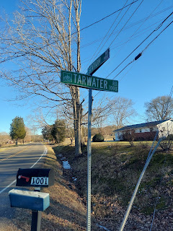

From the street sign, looking south on Tarwater Road where we would be driving.

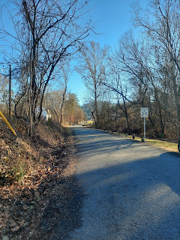

Scott took a few videos for me, since I was driving. What a good husband.

Video #1 on Tarwater Road: (1 min, 22 sec)

https://photos.app.goo.gl/vwJWVGSXLL4JDbQSA

He stopped filming as we came to this next scene. I wanted a photo of the horses, and I wasn't sure I wanted to go up the hill on such a narrow and slightly snowy road.

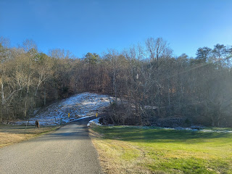

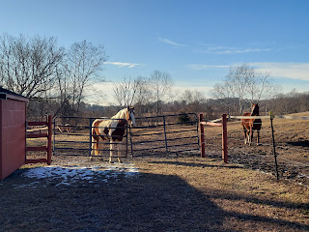

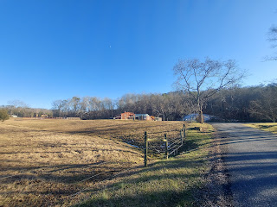

I chose to continue up the hill anyway, because I wanted to follow the entire length of Tarwater Road. And we had a nice SUV so I felt a little more comfortable about the road conditions . . .

Video #2: Tarwater Road (41 seconds)

https://photos.app.goo.gl/6KV4dfkx3tvxTJtN8

At the end of this section, I was thrilled to see a very old barn. I found a place to pull over and get a couple photos.

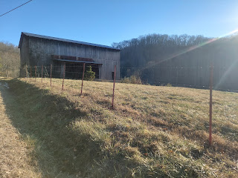

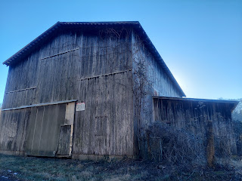

I walked across the street to visit with a couple guys who were in their driveway. They didn't know much about the history of the area, but they said there are plenty of Tarwaters still living around Knoxville. He suggested I go down into the "holler" behind the barn across the street to talk to some old guy that lives there, and that he would likely have some answers to my questions. But unfortunately, we had to get back on the road. I will just have to come back sometime soon and see what I can find out.

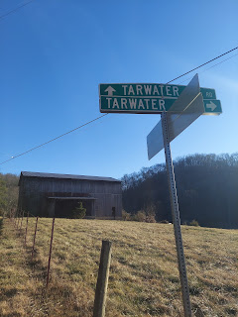

Video #3: Tarwater Road (44 seconds) This section was redneck country for sure. A couple of nice homes were sprinkled along the way, but it was mostly just a super narrow road surrounded by forest. It was really beautiful and peaceful, though, which was nice.

https://photos.app.goo.gl/EGa8KoWog7exKpMW7

Tarwater Road ended here, at the intersection of Neubert Springs Road. And yes, that's my shadow.

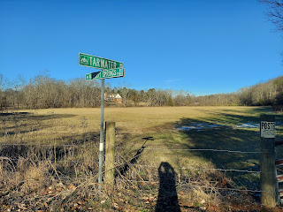

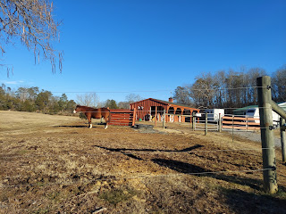

It felt so good to have something besides the Interstate to be prisoner to all day long. I've been craving more family history opportunities recently, so this was just perfect.

My Tarwater ancestors come through my paternal grandmother, Zola Eve Rawles. Her paternal grandmother was Louisa Jane Tarwater, daughter of Robert Holt Tarwater. My present-day cousins have told me that Louisa Jane was referred to as Grandma Yi (pronounced "Yee") and that she was an amazing cook.

Here is one of her recipes, as shared by my Aunt Juanita Brown Slay (my dad's older half-sister). She mentions that her mother learned this from Grandma Yi. The mother referred to below is my Grandma Zoe.

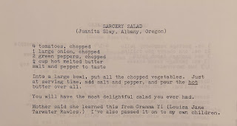

It felt like we drove and drove and drove for an eternity that day. By the time we finally got to our hotel in Memphis, we had been on the road for 15 hours, including a few gas stops and a brief lunch stop. We were so happy to flop into our comfy bed as fast as we could after checking in.

Video of Scott singing some of "Where I Find God" by Larry Fleet. He was a champ and did most of the driving that day. Scott, that is . . . (19 seconds)

https://photos.app.goo.gl/vkMrjqa3BTGsp6KC9

Friday:

I offered to start the day driving, since Scott did most of the long haul the day before. We didn't know that we were heading into a storm . . .

The small blue dot is where we were when Scott took this screenshot.

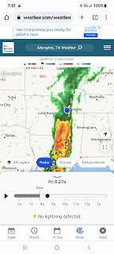

The downpour was significant. I had the wipers on high and everything was just blurry and wet for about an hour. Everyone was driving well under the speed limit during that time, including us. I was extremely grateful when I could actually see out the front windshield again and have something that my eyes could focus on.

Our drive on Friday consisted of getting across the entire state of Arkansas, which neither of us had ever been to. We hadn't ever been through Tennessee either, so that was fun.

Arkansas is basically a swamp. As we drove along, I was marveling at how mucky, muddy, and flooded all the farm fields were. I knew Arkansas had the record for the most rivers, streams and lakes in the U.S. (because Idaho is close behind them), but I didn't know that the whole state was under water, ha ha. Maybe they just had a ton of rain or something, but my goodness, it was a mess.

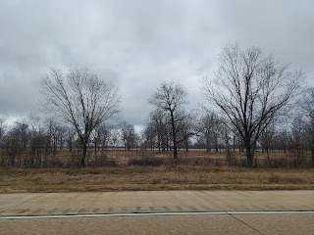

I drove for half the day, and Scott brought up the rear. I was so tired those last couple of hours so I wouldn't have been much good behind the wheel anyway. We logged and additional 7.5 driving hours on Day Two, not including any stops.

FINALLY we made it to Dallas and the AirBnB where the Whitworths were already waiting eagerly for us! We would have been there by lunchtime the day before if our flight hadn't been canceled. It was so disappointing that our time together would be cut down to a mere 24 hours. But we were determined to make the most of it.

I was able to give Abby and Gwen the Christmas gifts that I had hauled all the way from Italy in my suitcase. They were thrilled with everything, as I knew they would be. :)

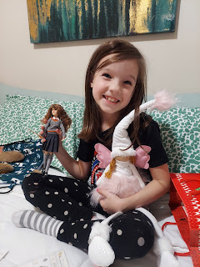

After we got settled in and had a chance to visit for a while, we piled into our cars to go roller skating at the Forum Roller World, just a few minutes away.

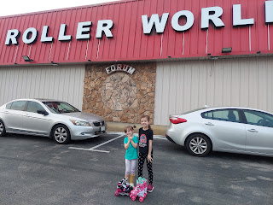

Abby and Gwen brought their own skates that they've been practicing with for months. I had to rent some skates, but they were pretty decent for being rentals. Amber and Weston tried skating as well, but their feet started hurting early on so they rested on the sidelines with Scott for some of the time.

Gwen took off right away with her "helper" and had absolutely no fear at all.

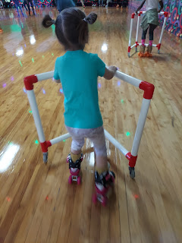

Video of Gwen taking off: (16 seconds)

https://photos.app.goo.gl/nKDGKXdZzbAv8A8z8

We got about 3 laps in before they had us all clear the floor for some races. They had different groupings, like 8 & under, 9-14, 15-18, and then 18+. When they invited anyone 18+ to come out onto the floor, NOBODY went out!! I was thinking hard and fast, like should I go??? I made a snap decision to just go for it, and I hopped up and skated out to the starting cone. Thankfully, another lady and then a man joined us for a total of 3 competitors. All we had to do was skate as fast as we could around the rink once to declare a winner. I got second place! It was super fun! I could see that my kids and granddaughters were super proud of me and that felt amazing.

Then it was back to "all skate". Abby wanted to borrow the "helper" for a bit to practice some of her fancy tricks, so Gwen skated along with Amber for a while.

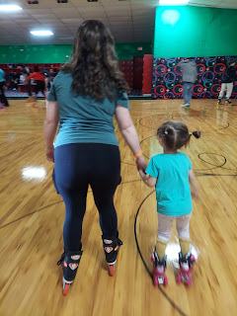

Video of Amber and Gwen skating together: (22 seconds)

https://photos.app.goo.gl/pmxLvv33Y7biZhA77

Video of Abby doing her tricks: (11 seconds)

https://photos.app.goo.gl/gYkC6UmnPKaabTk66

Another video of Abby skating: (20 seconds) For some reason it's sideways!! She is so fast though!

https://photos.app.goo.gl/LBGU7fKeTRTU4X4A8

A little bit later, a sweet little girl skated up to Gwen and me and wanted to introduce herself. She told us her name was Dream and she asked Gwen if they could be friends. Both girls are 5 years old. :)

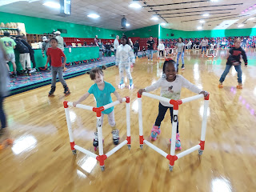

Video of Gwen and Dream skating together: (19 seconds)

https://photos.app.goo.gl/kaQL6SD5PTDSurtA8

Gwen could only take so much of Dream holding on firmly to her "helper" . . . eventually she asked Dream to let go (so she could be more independent and skate at her own pace I think).

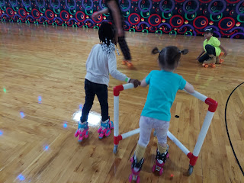

I kept passing this sweet baby who was learning how to skate. Her mom or her dad were always closeby, proudly watching her or helping her.  She looked like she was barely 2 years old!!

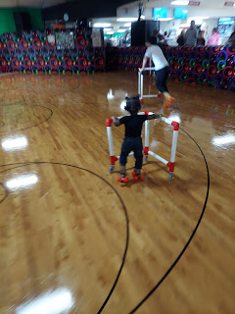

Gwen was very comfortable just holding onto my hand and skating, which was great! Every time I asked her if she was tired or if she needed a break, she responded with an enthusiastic "Nope!" She never stopped skating, not even once the entire time we were there!!

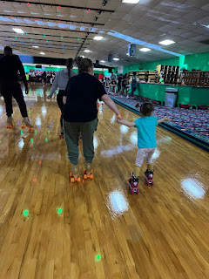

Eventually we did have to stop skating . . . much to mine and Gwen's disappointment. But it was time to head out to find some dinner. Weston had chosen an Ethiopian restaurant for us nearby. I've only had Ethiopian food one other time, when they used to live in San Antonio a few years ago, so I was eager to eat it again. Scott had never tried it before.

Weston did the ordering for us and everything was so delicious! We had to wait a while for our food because there were only 3 people running the restaurant that night, but it was worth the wait.

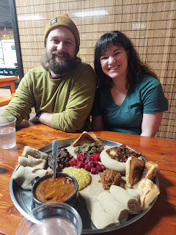

Weston served a mission in Ethiopia, Rwanda and Uganda from 2011 to 2013 and he is always craving Ethiopian food. They don't really have anything in the Shreveport area, so he was happy to be in Dallas with all the ethnic opportunities there.

Saturday:

We all slept really well and enjoyed a slower pace for the morning. We checked out of the AirBnB by 10:30 and went to meet with a Notary. When we deeded our Ford Ranger truck to Weston last summer and he had it shipped down to Louisiana, it's been one hurdle after another to get it registered in their state. The best solution was to wait until we were all together and then to take care of the paperwork with a notary so Weston can now have full ownership of the truck.

Once we got that taken care of, we went to Taco Bell for lunch and then on to SIX FLAGS!!!!!!

From the left: Amber, Scott is holding Abby, me, Weston and Gwen (whose hair kept blowing into her face in every single photo, ha ha)

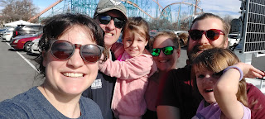

Gwen and Abby at the entry gate

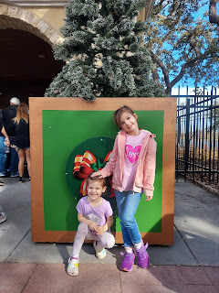

Gwen and Abby posing with "Queen Astrid"

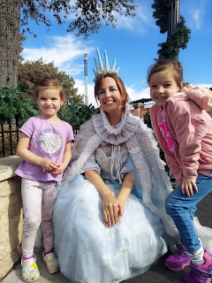

The girls played forever at a huge jungle gym / playground area as their first pitstop. Scott and I offered to hang with the girls while Amber and Weston went on some grownup rides.

Gwen and Abby on the train ride called Speedy Gonzales

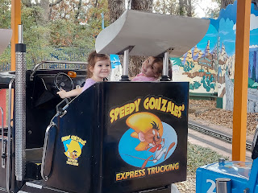

Video of them on the train ride: (24 seconds)

https://photos.app.goo.gl/ea1pHwD7tGRzKQhw7

Gwen and I went on a fun ride called Wile E. Coyote's Grand Canyon Blaster (basically just a kids' roller coaster). Abby went on a different ride with Poppa (Scott).

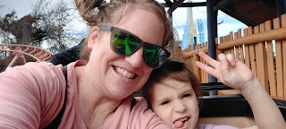

Weston invited me to try a ride called The Riddler. The way he described it sounded okay to me, but when we got close, I was like, Oh My Goodness.

Video of the ride before we got in line: (9 seconds)

https://photos.app.goo.gl/Vcon3kDirgHMeNGK7

The Riddler spins slowly while swinging back and forth, eventually getting as high as a 12 story building!! We waited in line for a long while before it was finally our turn. I didn't hate it. In fact, it was pretty fun!! I just haven't been on a big ride like that in quite a long time. We squealed and whooped and hollered during the ride together. Super fun!

We sent Amber and Weston off on a grownup date again, while we took Abby and Gwen on some additional adventures during our last hour in the park.

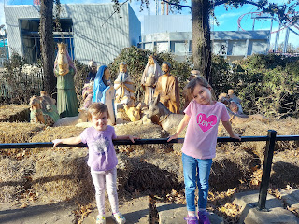

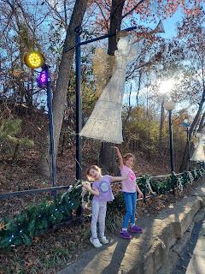

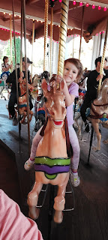

Video of Gwen riding on the Carousel: (9 seconds)

https://photos.app.goo.gl/5EDUeR95LxijvQay9

First I took a picture of the girls posing as Santa's elves, and then Abby graciously took one of Scott and me. She did a good job!

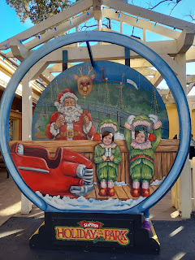

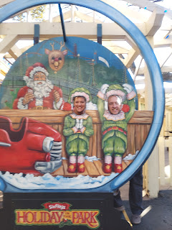

We found some tasty ice cream for the girls and they were kind enough to let me snitch some from their bowls. XOXO

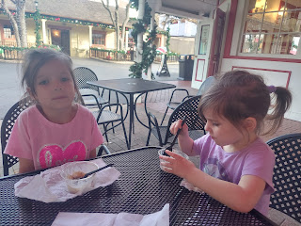

Six Flags has a petting zoo area with goats, pigs, miniature donkeys, sheep, and llamas. The girls loved seeing all the animals.

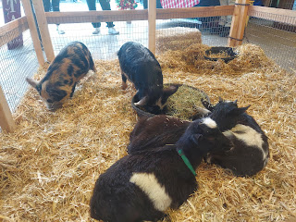

Jack would have gone nuts for the sheep, ha ha. His favorite show to watch is called Shawn the Sheep, which might explain his obsession with sheep in general . . . it's a super cute claymation show, similar to the movie Chicken Run. When he refers to any sheep, he calls out for "Baaaa". How cute is that!?!

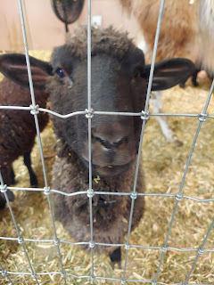

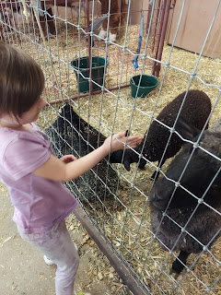

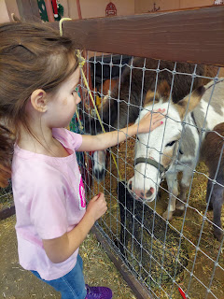

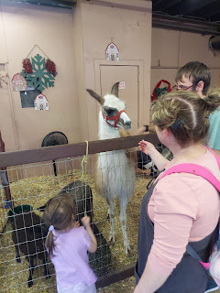

Amber got this darling photo of Gwen and me as we waited in line for our roller coaster. :)

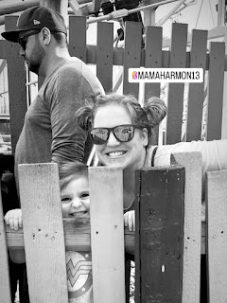

At 4:00 we had to hurry back to our cars in the parking lot so that Scott and I could head to the airport. We were so sad to part ways with the girls (and their parents), but we look forward with excitement to the spring when we can see them again. I'll see them in March before I fly back to Italy, April for Abby's baptism, and then they will fly over to Italy in May and spend a whole month with us there. We have to cling to these future plans to help us get through the separation right now.

We made good time getting to the airport, turning in the car, and getting through security to our gate. Thankfully we were flying on American Airlines this time, and everything was on time and picture perfect.

For dinner, since Jacob is always asking what everyone is eating every night and wants photos, this is what we shared while we waited for our plane to arrive. Not the healthiest week on record for us as far as food goes, but it's hard to make good choices under these type of circumstances. (traveling, eating out, being tired, etc)

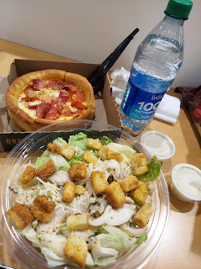

After 3.5 hours in the air, we landed in Idaho Falls. The picture below is blurry because there was ice on the window . . . Yes, we are back in the land of the frigid cold.

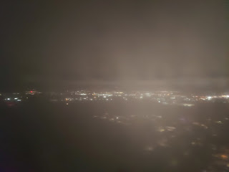

Our neighbor, Kim Parkinson, picked us up at the airport and brought us home. It felt so good to step foot in our own house once again!! Scott went from room to room, joyfully remembering everything as he went along. He had forgotten how beautiful it was after being gone for 9 months. I say beautiful not in a braggy way, but because SCOTT has done so many amazing renovation projects throughout the house over the years, and he has helped to make it so beautiful.

After puttering around for a while checking on things, we finally tucked ourselves into bed for the night.

Sunday:

Happy NewYear! Scott woke up EARLY, around 6 a.m., while I woke up closer to 7:30. When I found him, I asked him what he'd been up to so far. He excitedly recounted how he had changed some light bulbs, checked on this or that, etc. He was so happy! He is so adorable.

We started opening all the packages that piled up in the days before we got home. One of the packages was a beautiful crocheted afghan that my friend, Jenn Caudle made for me. She must have known that my favorite color has been YELLOW my entire life. What a sweet and thoughtful thing to do. She is such a wonderful friend!

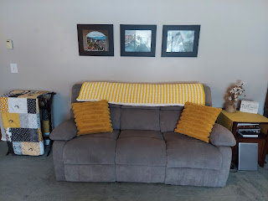

It was so great to see all of our friends and neighbors at church. Some of the young women that I used to work with came running over to squish me in a huge hug. I suggested that we make roller skating a weekly event while I'm in town, to which they squealed with delight and promised to join me as often as they can. (I want to make this a regular form of exercise when I'm home.)

During Sacrament meeting, I received a text from Peter Vance letting us know that Sophie (their sweet Maltese dog that we have helped take care of for many years) passed away Saturday night. My eyes immediately filled up with tears as I thought about sweet Sophie chasing squirrels in doggy heaven now.

After church, we drove over to the Vances house to give them hugs of condolence, but only their oldest daughter, Brittany was home. (She is Amber's age - 28). The rest of the family is on vacation in Costa Rica so they weren't home when Sophie died. Brittany shared with us that on Friday Sophie got a burst of energy and went tromping through the snow in the back yard to chase a squirrel or two. But on Saturday, New Year's Eve, she wasn't doing well the entire day and passed away by the end of the night. Brittany was pretty emotional as she spoke, understandably so, since Sophie has been a member of their family for about 15 years.

I hugged her more than once, and gently told her that she did all she could to care for Sophie and to not beat herself up by thinking there was more she could have done. She seemed to appreciate my comforting words. Once the rest of the family is home, I'm not sure if they plan to have a memorial service or not, but I'm sure they will do something to honor sweet Sophie. She was the most perfect dog ever.

Next, we drove up to Rigby to see Scott's parents and have lunch with them. It was so wonderful to see them again! As soon as we walked through the door, I gave my father-in-law a very quick hug because I could see that his gaze was mostly on Scott, whom he hadn't seen in 9 months. :)

While I helped Coy with some last minute preparations for the meal, Scott and his papa sat down and discussed what he's been doing in Italy all these months. Phil retrieved his very large map of Africa, which helped as a nice visual aid while Scott explained how their task force has been overseeing the 53 countries along with some of the particulars.

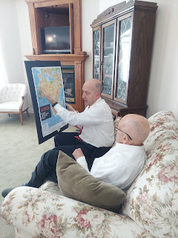

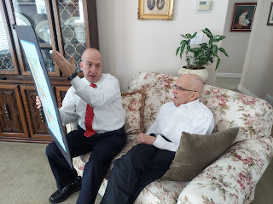

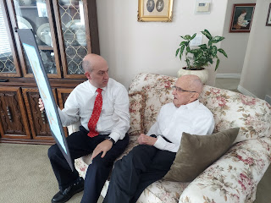

Lunch was absolutely spectacular!! I told Coy that if I could only eat one meal every day for the rest of my life, this would be it. :)

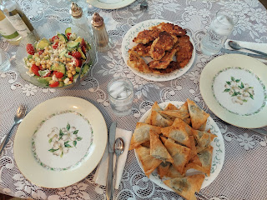

Here are the recipes she used:

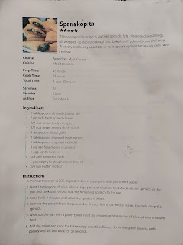

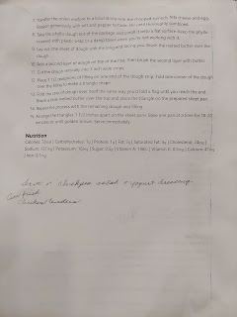

The Chickpea Salad was particularly divine. We drizzled a little bit of rosemary olive oil (from Italy) on it, along with a sprinkling of vinegar, and mmmmm. So good.

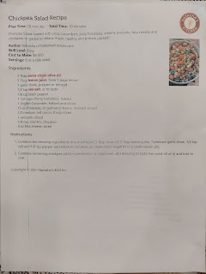

Best chicken I've ever had. Hands down.

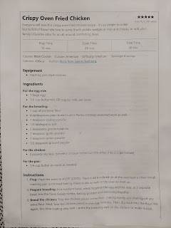

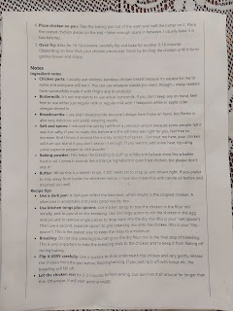

We visited for a while and enjoyed just being in the same space. It's been so long for Scott, especially. How nice to spend an afternoon together.

Coy showed me the family tree that she updated and made a few changes to recently. She's had a family tree with photos of everyone for YEARS, but with some branches making more babies than others, the tree was getting a little tangled. So she painted a new background, and rearranged the branches to allow more room for the growing list of descendants. It is quite a showstopper!

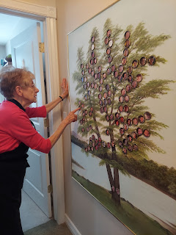

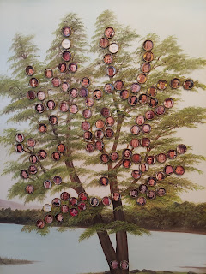

The sun was setting on our way back to Idaho Falls. The world is WHITE here, whereas in Italy everything is very GREEN. It will be an adjustment, but so far so good.

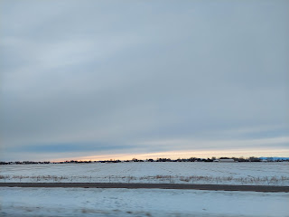

We had dinner with our friends that live a couple of streets over, Scott and Jen Anderson. I was grateful that they invited us to join them (even though I was so tired), because we had such an empty fridge and not much of anything to prepare on a Sunday - and it was also a national holiday, which meant that the grocery stores would be closed. We'd have to wait until Monday to get stocked up on groceries . . .

We had a nice meal with the Andersons and several members of their family. They made ham, funeral potatoes, rolls, jello salad, green salad, etc. Scott used to serve in the bishopric with Scott Anderson. It was funny because the Bishop worked with Scott and Scott.

Oh - earlier in the week, my Dad sent these photos of the crazy flooding they've been having where he lives. From the city of Willits, CA, to get to his house, you have to drive a few miles north before you veer off onto a dirt road that goes deep into the forest for a few miles. With the storm that came through, it turned that usual dirt road into quite a mess!!

The creek that typically runs alongside the dirt road is hardly a separate entity below. It all looks like one raging current! I'm just glad they could somehow get through all of that and home to safety.

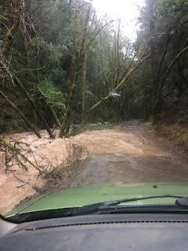

Rain gauge below: Dad said that over the course of 24 hours, they received about 8 inches of rain!! Yikes!!

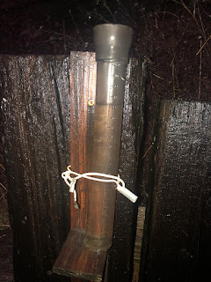

Lastly, I received this photo from Kylie on NewYear's Eve.

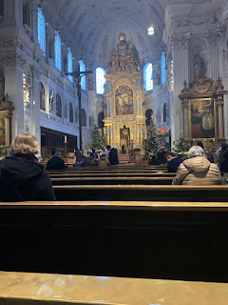

I asked where she was . . . it was reminiscent of when we visited Vatican City with the Garners back in October. But no, she was in Munich, Germany!! What a beautiful church. I'm glad she is able to get out to see some sights before she leaves Europe soon to come back to Idaho.

HAPPY NEW YEAR!!!!!